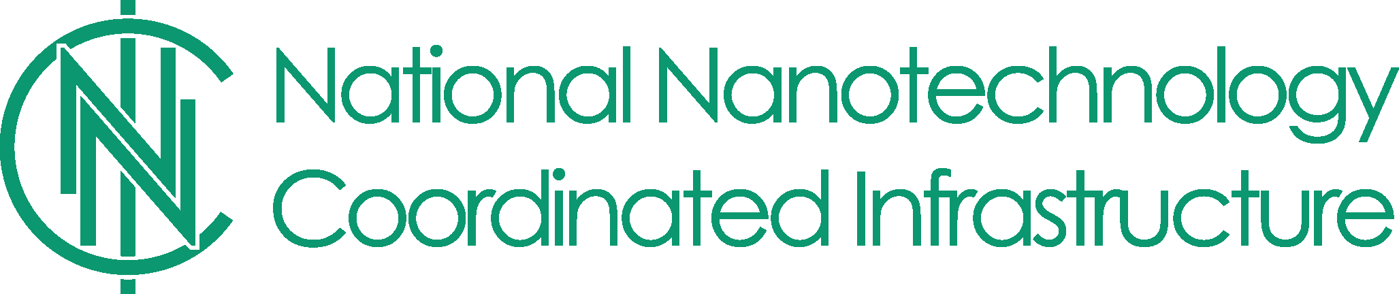

2022 NNCI Nanotechnology Entrepreneurship Challenge (NTEC)
Supporting student-led nanotechnology innovation and entrepreneurship

NTEC 2022 is supported by participating sites of the NSF-funded National Nanotechnology Coordinated Infrastructure (NNCI). Student-led teams can receive funding or in-kind facility access and mentorship to develop nano-enabled innovations for global sustainability challenges. NTEC awards:
- Provide resources to help students use nanotechnology to solve real-world problems in society
- Encourage innovation and entrepreneurship through diverse, student-led teams involved in sites of the NSF-funded National Nanotechnology Coordinated Infrastructure
- Educate students on the technology transfer process and programs like NSF I-Corps
- Encourage commercialization of original ideas OR IP available for license through NNCI sites

Awards
Multiple cash and in-kind awards are available and all winning teams are encouraged to participate in the Virtual NNCI NTEC Accelerator Program. Regular NTEC teams receive up to $500 and NTEC teams affiliated with minority serving institutions can apply for an NTEC Diversity Award of up to $1,000 per team. Awards are used for qualifying materials purchases and instrument time at participating NNCI sites. The number of awards will depend on the availability of funds and quality of proposals received.

Key Dates
- February 11th, 2022: One-page summary due (Attachment A)
- March 7th, 2022: Awardees announced

Eligibility
- Teams must be student led, but an NNCI-affiliated faculty or staff mentor is required
- Student leads must be currently enrolled at an NNCI site (undergraduate or graduate)
- To apply for an NTEC Diversity Award, student leads must be enrolled as an undergraduate or graduate student at a minority serving institution OR, the leader may have participated in a research experience for undergraduates (REU) program at a participating NNCI site

Application, Review Process, and Review Criteria
To apply, complete Attachment A (1 page limit) and email it to Dr. Matthew Hull. Winning teams will be selected based on the following criteria:
- Merit of the innovation proposed and its expected commercialization potential
- Quality of the technology transfer strategy and future plans
- Reasonableness of the budget and budget justification
- Team participation in the virtual NTEC Accelerator program
- Availability of funds

Questions and Applications: Contact Dr. Matthew Hull
Attachment A. NNCI NTEC Application (Limit to 1 page)
Title:
Student Leader (name/email) and Level (BS, MS, PhD):
Faculty/Staff Mentor (name/email):
NNCI Site Affiliation (more info):
Award Type (pick one): |  | 1) Regular ($500) OR 2) Diversity Award ($1,000)

1. Briefly describe your innovative idea OR the technology you wish to license from an NNCI site.

2. What customer/societal problem are you attempting to address? How does your idea offer a solution?

3. How does nanotechnology offer a competitive advantage in addressing the problem noted above?

4. Briefly describe the initial market(s) for your idea, the market size, and the target customer.

5. Budget: Briefly describe what you plan to accomplish with the award and complete the table below.

6. Complete the budget table
Budget Item | Amount | Brief Description
Materials & Supplies | $ -
Analytical (e.g., NNCI node) | $ -
Travel (Diversity Award only) | $ -

7. Faculty mentorship statement: Briefly describe the nature of your support for the proposed project.

